1. **Multiple image gallery**

<!DOCTYPE html>

<html lang="en">

<head>

<meta charset="UTF-8">

<meta name="viewport" content="width=device-width, initial-scale=1.0">

<title>Document</title>

</head>

<body>

<h1>Image Gallary</h1>

<img width="200px" height="200px" src="/Media/1469437.jpg" alt="">

<img width="200px" height="200px" src="/Media Assignment/01wallpaperflare.com_wallpaper.jpg" alt="">

<img width="200px" height="200px" src="/Media Assignment/2230846.jpg" alt="">

</body>

</html>

Output:

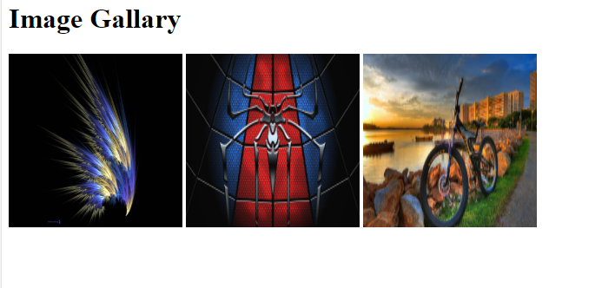

1. **Video and audio**

<!DOCTYPE html>

<html lang="en">

<head>

<meta charset="UTF-8">

<meta name="viewport" content="width=device-width, initial-scale=1.0">

<title>Video/Audio</title>

</head>

<body>

<h1>Video Contents</h1>

<video width="280px" height="250px" src="./COKA COKA Song.mp4" controls>Video Play</video>

<h1>Audio content</h1>

<audio src="./AATE JATE KHOOBSURAT.mp3" controls>Audio play</audio>

</body>

</html>

Output:



1. **Modify previous assignment video and audio play automatically .**

<!DOCTYPE html>

<html lang="en">

<head>

<meta charset="UTF-8">

<meta name="viewport" content="width=device-width, initial-scale=1.0">

<title>Video/Audio</title>

</head>

<body>

<h1>Video Contents</h1>

<video width="280px" height="250px" src="./COKA COKA Song.mp4" controls autoplay>Video Play</video>

<h1>Audio content</h1>

<audio src="./AATE JATE KHOOBSURAT.mp3" controls autoplay>Audio play</audio>

</body>

</html>

1. Ifram use for Physics wallah Wikipedia

!DOCTYPE html>

<html lang="en">

<head>

<meta charset="UTF-8">

<meta name="viewport" content="width=device-width, initial-scale=1.0">

<title>Physics Wallah</title>

</head>

<body>

<iframe src="https://en.wikipedia.org/wiki/Physics_Wallah" frameborder="0" width="750px" height="600px"> physics wallah</iframe>

</body>

</html>

Output: 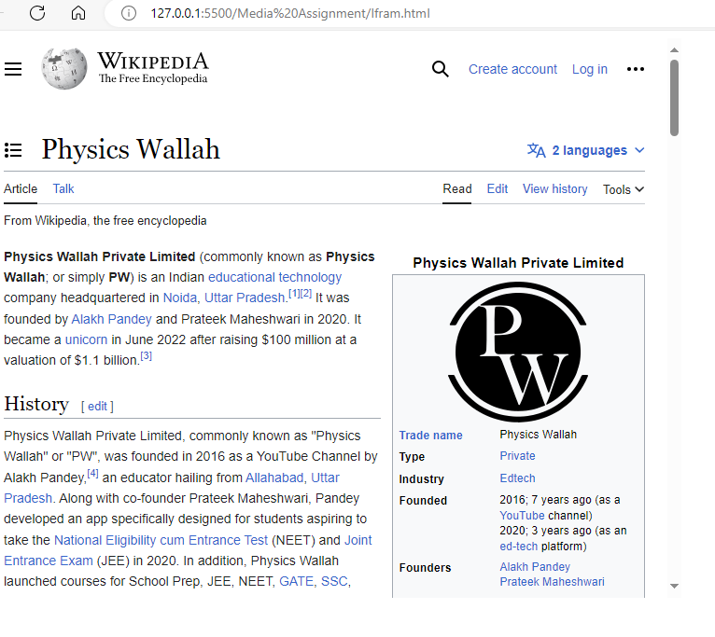

1. (A). Sign up page

<!DOCTYPE html>

<html lang="en">

<head>

<meta charset="UTF-8">

<meta name="viewport" content="width=device-width, initial-scale=1.0">

<title>Login page</title>

</head>

<body>

<h1>Sign up Page</h1>

<form >

<label for="firstname">First Name :</label>

<input type="text" placeholder="Mukesh" name="firstname" id="firstname">

<br>

<label for="lastname"> Last Name:</label>

<input type="text" placeholder="Kumar" name="lastname" id="lastname">

<br>

<label for="email"> Email:</label>

<input type="text" placeholder="ujn@gmail.com" name="gmail" id="gmail">

<br>

<label for="password">Password:</label>

<input type="text" placeholder="***********" name="password" id="password">

<br>

<label for="confirmpassword">Confirm Password:</label>

<input type="text" name="confrimpassword" placeholder="**********" id="confirmpassword">

<br>

<label for="age">Age:</label>

<input type="text" name="age" placeholder="30" id="age">

<br>

<label for="gender">Gender:</label>

<label for="male">Male</label>

<input type="radio" value="male" name="male" id="male">

<label for="femail">Female</label>

<input type="radio" value="female" name="femail" id="female">

<label for="other">Other</label>

<input type="radio" value="other" name="other" id="other">

<br>

<label for="term">Terms:</label>

<input type="checkbox" name="term" id="term" required > i agree terms and conditions

<br>

<input type="submit" value="Submit">

</form>

</body>

</html>

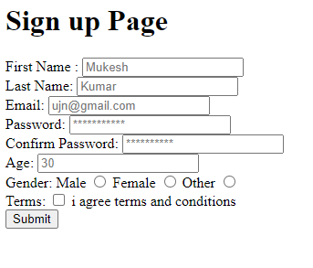

b. sign in page

<!DOCTYPE html>

<html lang="en">

<head>

<meta charset="UTF-8">

<meta name="viewport" content="width=device-width, initial-scale=1.0">

<title>login</title>

</head>

<body>

<h2>login the page </h2>

<label for="username">Username :</label>

<input type="text" name="username" placeholder="sad@gmail.com" id="username">

<br>

<label for="password">Password ;</label>

<input type="text" name="password" placeholder="passwod" id="password">

<br>

<input type="submit" value="Submit">

</body>

</html>

Output:

